Lab – 3 – BASH Scripting
Part 1: Bash and Bash scripts. (20 marks)
Use a command to check the types of Shells available on your system. The file /etc/shells give an overview of known shells on a Linux system:

1. Where is the bash program located on your system?
usr/bin/bash
2. Use the --version option to find out which version you are running. (Add screenshot)
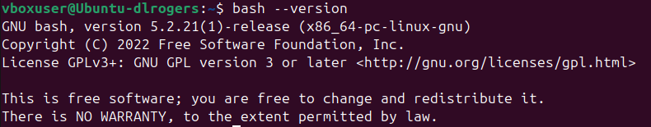
3. Why is command bash_profile used in Linux?
This file is a login shell config file that executes commands automatically when a user logs in. It sets important environment variables such as PATH, EDITOR). It also runs any initialization scripts and sets user environment variables such as aliases and prompt.
4. Which shell configuration files are read when you log in to your system using the graphical user interface and then opening a terminal window?
/etc/profile or ~/.bash_profile, whichever exists first.
5. What is the .bashrc file in Linux? (Add screenshot of cat .bashrc)
It is a user-specific config script that runs every time a new interactive non-login shell is opened. It contains aliases, functions and environment customizations.
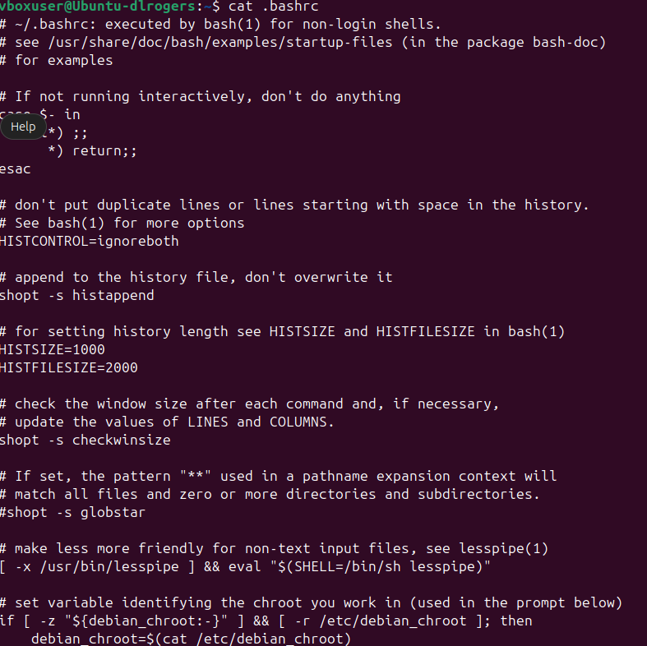
6. What is an interactive shell and login shell?
An interactive shell is a shell that interacts with the user. A login shell session starts after you open a terminal window or run BASH manually.
7. Are the following shells interactive shells? Are they login shells?
  - A shell is opened by clicking on the background of your graphical desktop, selecting "Terminal" or such from a menu. Interactive
  - A shell that you get after issuing the command ssh localhost. Both
  - A shell that you get when logging in to the console in text mode. Both
  - A shell obtained by the command xterm &. Interactive
  - A shell opened by the mysystem.sh script. Neither
  - A shell that you get on a remote host, for which you didn't have to give the login and/or password because you use SSH and maybe SSH keys. Both
8. Can you explain why bash does not exit when you type Ctrl+C on the command line?
Ctrl+C sends an interrupt signal to foreground process not the BASH shell.

9. Display directory stack content. (Add screenshot)
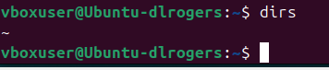
10. Display hash commands for your current shell session. (Add screenshot)
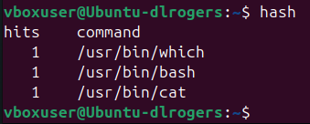
11. How many processes are currently running on your system? Use ps and wc, the first line of output of ps is not a process! (Add screenshot)
206
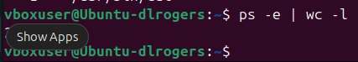

12. How to display the system hostname? Only the name, nothing more! (Add screenshot)
hostname
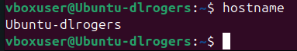
13. Write down the properties of good scripts.

1. Clear Purpose | The script should solve a defined task or automate a repeatable process.
2. Readability | Use indentation, comments, and meaningful variable names.
3. Portability | Should work across systems (use POSIX-compatible syntax).
4. Error Handling | Include checks for invalid input or missing files.
5. Efficiency | Use built-in commands and loops efficiently to save system resources.
6. Modularity | Divide logic into functions for reusability.
7. Use of Variables | Define constants and parameters using variables instead of hardcoding values.
8. Proper Output | Provide clear messages and results; redirect errors appropriately.
9. Exit Codes | Return meaningful exit statuses (0 for success, non-zero for errors).
10. Documentation | Include header comments stating author, purpose, and usage.

Part 2: Writing and debugging scripts. (20 marks)
- Write a script using your favorite editor. The script should display the path to your home directory and the terminal type that you are using. Additionally, it shows all the services started up in runlevel 3 on your system.
(Hint: use HOME, TERM and ls /etc/rc3.d/S*) (Add screenshot).
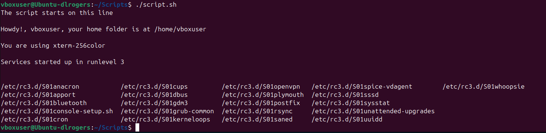
Add comments in your script. (Add screenshot).
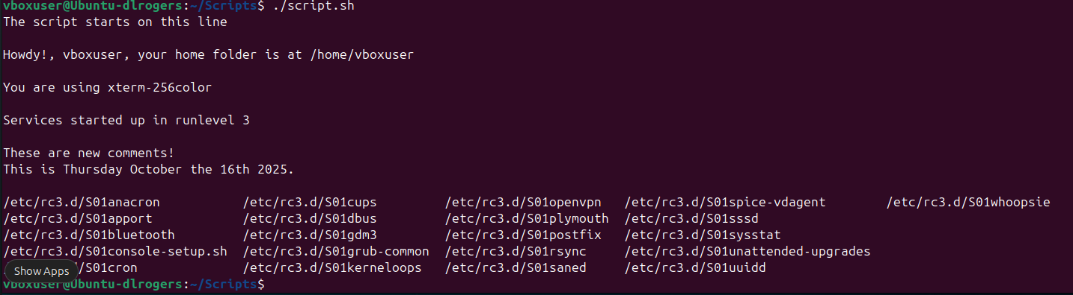
- Add information for the users of your script. (Add screenshot).
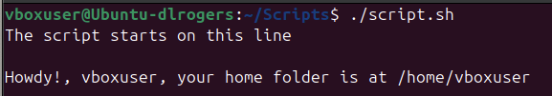
- Change permissions on your script so that you can run it. (Add screenshot).
- Run the script in normal mode and debug mode. It should run without errors. (Add screenshot).
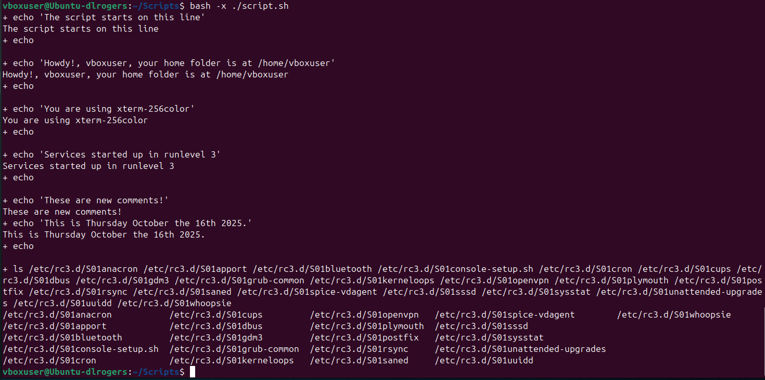

- Make errors in your script: see what happens if you misspell commands, if you leave out the first line or put something unintelligible there, or if you misspell shell variable names or write them in lowercase characters after they have been declared in capitals. Check what the debug comments say about this. (Add screenshot).

Removed $ from in front of $TERM.

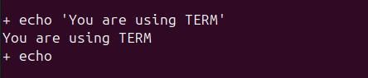

Removed quote marks.

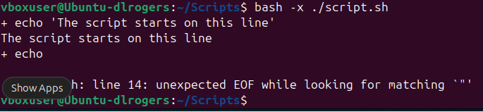

Part 3: The BASH Environment. (25 marks)

1. Create 3 variables, VAR1, VAR2, and VAR3; initialize them to hold the values "thirteen", "13" and "Happy Birthday" respectively. (Add screenshot).
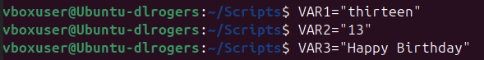
2. Display the values of all three variables. (Add screenshot).
3. Are these local or global variables? Explain in brief.
These are local variables and only exist in this shell session.
4. Remove VAR3. (Add screenshot).
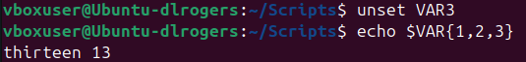
5. Can you see the two remaining variables in a new terminal window? (Add screenshot).
No.
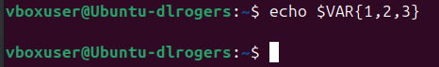
6. Edit /etc/profile so that all users are greeted upon login (test this). (Add screenshot).
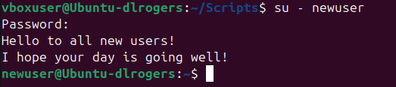
7. Write a script in which you assign two integer values to two variables. The script should calculate the surface of a rectangle that has these proportions. It should be aired with comments and generate elegant output. (Add screenshot).
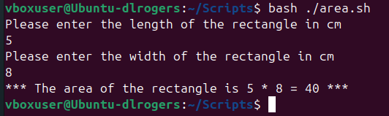
Part 4: Write a bash script. (25 marks)

Use an if/then/elif/else construct that prints information about the current month.
The script should print the number of days in this month and give information about leap years for the entered value of the Year as shown in the output below. (Add screenshot).
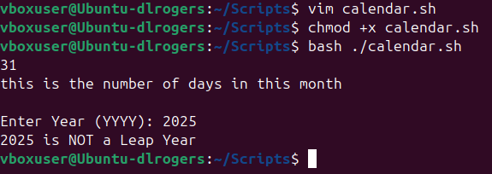
Part 5: Give a brief explanation of the Case statement used in Bash scripting. (10 marks)
Run the following bash script and explain the output. (Add screenshot)
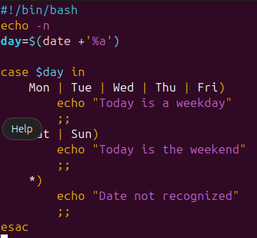
Answer –
- Uses date +'%a' to get the current 3-letter weekday abbreviation
- The case statement checks which day it is:
  - Mon–Fri: prints “Today is a weekday.”
  - Sat–Sun: prints “Today is the weekend.”
  - Anything else: prints “Date not recognized.”

